1.1

# 4 points for showing the correct value

# 3 points for using the correct formula

# 3 points for using the correct values for n and k

1.2

# 3 points for generating array with values

# 4 points for using correct or formula logic to create the array where n, k and the p.

# 3 points for the correct range and number of elements, the first and last value should be correct and match mine.

1.3

# 3 point The correct formula with either special.comb or special.factorial

# 4 points -correct range of values.

# 3 points The resulting value should match below up to the 3 decimal places

Question 2

# 3 points for using a loop or array comprehension

# 1 point for using correct formula

# 2 point for using correct range

# 1 points for testing it

# 1 point to compare with previous solution

# the answer should match below to the 4 significant digits with mine.

# 2 points for showing your final number

Question 3

There is 2 approaches to solve this.

Approach 1

# 3 point for using two calls to prob_at_most

# 1 point for using correct p and its value

# 3 points for using correct formula

# 2 points for summing the probabilities

# 1 point for showing the value below to the correct 3 significant digits.

Approach 2

# 1 point for using correct n

# 1 point for using correct p

# 2 point for using range of correct low and high end

# 3 points for using correct formula

# 2 points for summing the probabilities

# 1 point for showing the value below to the correct 3 significant digits.

Question 4

# 8 points for showing or printing the whole dataframe

# 1 points for using drop to remove the column if it already exists.

# 2 for adding the series into the fruit_info dataframe

Question 5.1

# 3 points for using correct filter

# 3 points for showing all the columns

# 4 points for showing the same correct rows as mine

Question 5.2

# 2 points for using dataframe

# 2 points for using str functions startwith

# 2 points for using str function endswith

# 2 points for showing 10 first names

# 2 points for correct search results

Question 5.3

# 2 points for filtering correct from the DF

# 1 points – using correct columns

2 points for y and x axis labels

1 points for title

1 point for year on x

1 point count numbers on y

2 points for showing graph similar to mine

Should look like this:

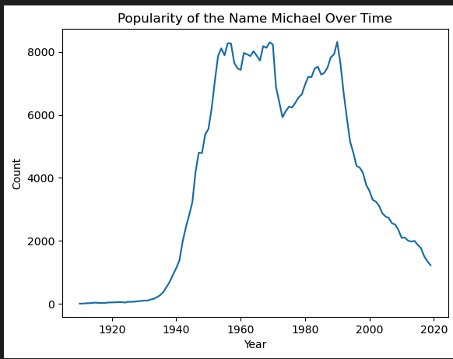

Question 5.4

2 point for using groupby or some technique that produces the unisex list

2 points for counting colums within the groupby

2 points for printing the correct count (over 1000 unisex names)

2 points for testing your names in the unisex subset

2 points for testing negative results in the unisex subset